Easy Origami Elephant Step 1: Start with a square 6" x 6" (15cm x 15cm) origami paper color side down.
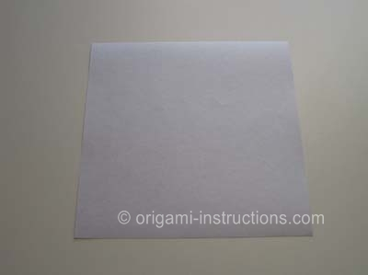
Easy Origami Elephant Step 2: Fold it in half (valley fold) and open it back up.
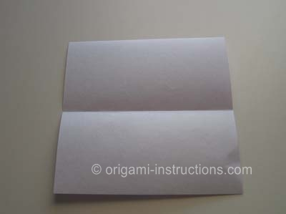
Easy Origami Elephant Step 3: Now fold it right to left and open back up.
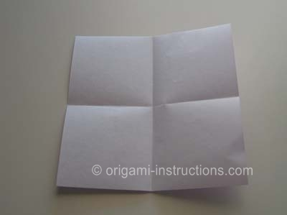
Easy Origami Elephant Step 4: Now, you will fold the top left corner at an angle to meet the center crease.
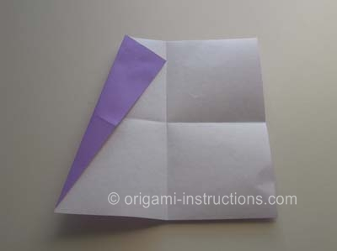
Easy Origami Elephant Step 5: Fold the paper in half - bring the top edge down to meet the bottom edge. (Mountain Fold).
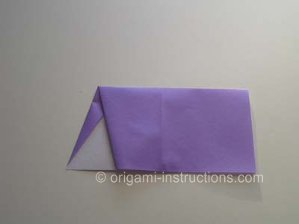

Easy Origami Elephant Step 6: Now fold the left side to meet the center crease:
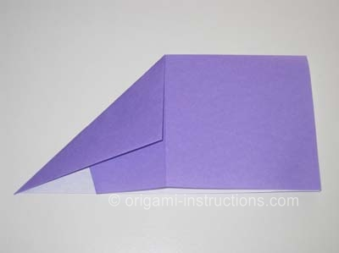
Easy Origami Elephant Step 7: Open up the fold you just made.
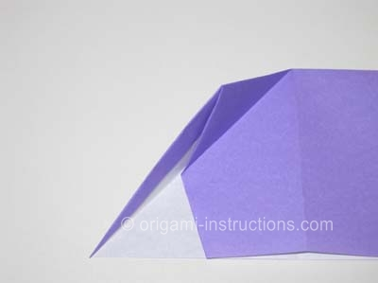
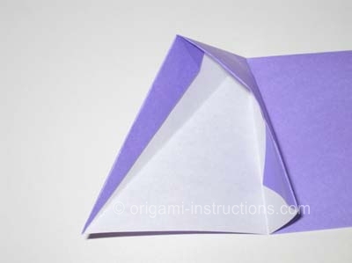
Easy Origami Elephant Step 8: Make a squash fold.
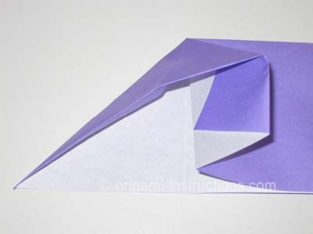
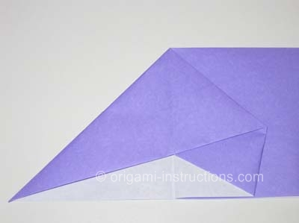
Easy Origami Elephant Step 9: OK, you can either stop here and draw in the eyes or continue to Step 10.
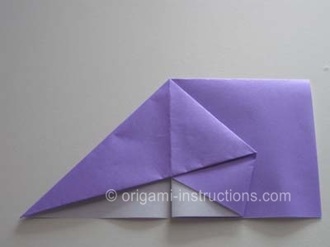
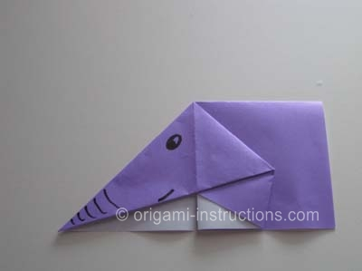
Easy Origami Elephant Step 10: Make a small fold on the top right:
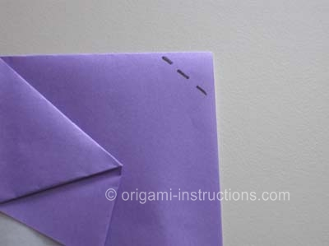
and get this easy origami elephant!
